Tool Setup: IDEs and Source Control
Table of Contents
Introduction 1
IDE – Integrated Development Environment 2
Visual Studio Community 3
Code::Blocks 3
Xcode 3
Sample Program 4
Visual Studio Community 5
Code::Blocks 6
XCode 7
Source Control 8
Hello, GitHub! 8
Register an Account 8
Download GitHub Desktop 9
Create a Repository from GitHub Desktop 9
Create a Repository from the Web 10
Your GitHub 11
Other Peoples' GitHub 11

Introduction
Before we get started programming, we need to set up our development environment. If you're using a school computer lab, the machines may already have Visual Studio and Git on them. If you'd like to program at home, you can install free tools to use.

IDE – Integrated Development Environment

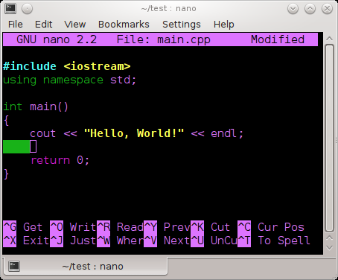  We are going to start out by using an IDE to write our C++ code, even though using an IDE isn't required to write a  C++ program.  You could write a program with a normal text editor (think: Notepad, but don't use Notepad – it is terrible.),  and then build your program with a compiler (this builds it into an executable file.) | Writing a simple C++ program with nano, a Linux-based text editor.
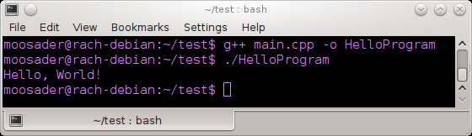  This could be useful if you're on a machine that doesn't have a Graphical User Interface, or tunneling to a server with ssh or PuTTY. (But, that's another class!) | Building a simple C++ program with g++ and running it in a terminal.

An IDE is an Integrated Development Environment, which generally means your fancy text editor (with syntax highlighting!), debugging tools, and it usually has the build/compile option available from within the program, so you don't have to compile externally.

Note that the IDE is not the compiler! The compiler is a separate piece, and many IDEs let you use any compiler you want. Additionally, it (generally) should not matter which compiler you use for writing C++ programs – C++ is a standardized language.  Some compilers might not support the newest C++ standards and some might, but for the most part we will be covering C++98. | Names of some compilers...  - CL (Used in Visual Studio)  - gcc, g++ (For Linux)  - mingw (Windows version of gcc)  - Clang

Visual Studio Community  https://www.visualstudio.com/en-us/products/visual-studio-express-vs.aspx  Platforms: Windows  Visual Studio Community is the free version of visual studio, meant for “individual developers, open source projects, academic research, education, and small professional teams.” (So, basically, don't run your gigantic corporation with VS Community) | Code::Blocks  http://codeblocks.org/  Platforms: Windows Linux OSX  Code::Blocks is an open source IDE, available on multiple platforms. You can use multiple compilers with it.  If you want something more light-weight than Visual Studio, this is what I would recommend!  Note: If you're running it on Windows you should download the version with mingw  (Downloads > Binaries >  codeblocks-13.12mingw-setup.exe )

Xcode
https://developer.apple.com/xcode/
Platforms: OSX
Xcode is Apple's IDE for using their languages, but also supports languages like C++.

Sample Program
Got something downloaded? Let's write a quick program to make sure everything is in working order!
We will step through setting up the IDE below, but for now here's the sample code we will use:
#include <iostream>
int main()
{
std::cout << "hello!" << std::endl;
return 0;
}

We will go over the basics of C++ later, but here's a quick rundown:
- #include is how we tell our program that we're using a Library, where a Library is essentially a bunch of code that you or somebody else has already written, set up to be reused across multiple programs.
- iostream is part of C++ standard library – it allows you to use Input and Output as a stream. (We will learn more about what “Streams” are later!)
- int main() is our program entry-point. Every program begins with the main function.
  - int means Integer – our main program will be required to return an integer at the end.
  - The return 0; is doing this – it is saying that there were no problems. We used to return different error codes when certain things went wrong (and 0 means nothing went wrong), but there are better ways to handle errors these days.
- std::cout is short for standard console output – this is how we tell the program that we're going to write some text to the screen.
- std::endl is short for standard end line – You can also use “\n” within the quotation marks, or you can throw an endl in there for a new line.

Visual Studio Community
- Go to File > New > Project…
- In the search bar, look up “C++”.
- If “Install Visual C++ 2015 Tools for Windows Desktop” shows up, you will need to install it before you can make a C++ project.
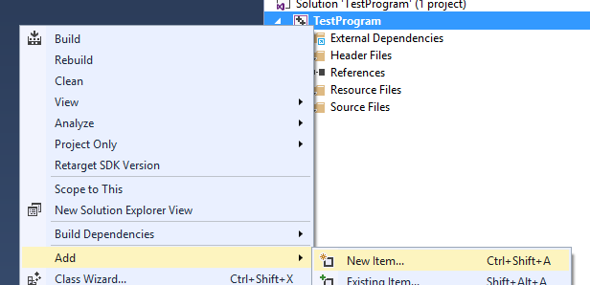
- If “Empty Project” shows up, select that. Give your project a Name and a Location, on the bottom of this window.
- Right-click on your project file in the Solution Explorer and click Add > New Item…
- Select C++ File (.cpp) and enter a name like main.cpp. Then hit Add.
- In the source file, copy-paste the sample program.
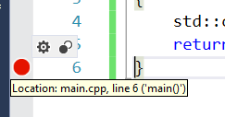
- Go to Build > Build Solution, and once it is done click the play button (Debug > Start Debugging).
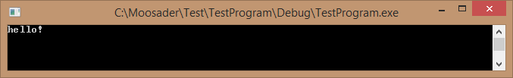
- The program opens, but then closes immediately because it never needs user input! A quick way to handle this is to add a breakpoint to the end of the program and debug again. (Left-click the gray margin by the side of your code).

- Click the Continue button in Visual Studio to let the program finish and close.

Code::Blocks
- Go to File > New > Project...
- Select Empty project and hit Go.
- Enter a Project title, and browse to a Folder to create project in. The Project filename will be auto-populated, but you can change it if you'd like.
Code::Blocks will automatically add a sub-folder with your project's name.
Click Next >
- The defaults for Debug and Release are fine. Click Finish.
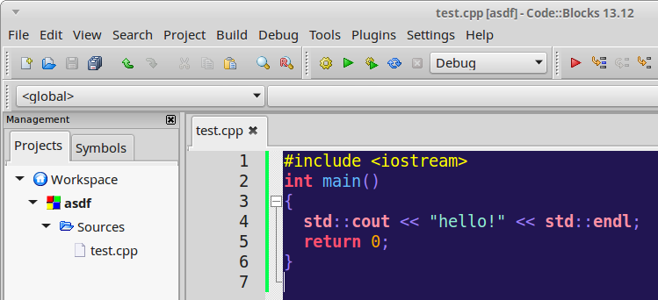
- Go to File > New > Empty file (CTRL+SHIFT+N). It will ask whether to add it to the active project – select Yes. Save the file as main.cpp (or anything.cpp).
- It will ask whether this file is for both Release and Debug. Have them both checked and click OK.
- Paste the sample code into your main.cpp file.
- Go to Build > Build and run.
- It should build, and a console window should pop up:
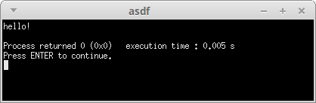

Xcode
You can get Xcode from the App Store on OSX.
- When you open Xcode, it will ask what template you'd like to use for a project. Select Command Line Tool.
- Set a Product Name and set the Language to C++. Then click Create.
- It will automatically create a main.cpp file. Open it up, and paste the sample code in.
- Select Product > Run and it will build and begin the program.
- The program output will show up in bottom pane.
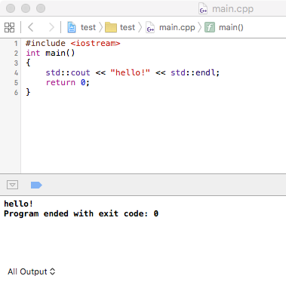

Source Control
Now that you have an IDE set up, we need to talk a little bit about Source Control (aka Revision Control, aka Version Control...)
Almost any software or web development shop that you will work at will use Source Control (and if they don't, you should not take that job!), but Source Control can also be useful for a single-person team.
Source control lets you...
- Back up your work at regular intervals to a server
- Keep track of the changes you've made to each file over time.
- Restore backups at any point in history, for all files or one specific file.
- Access your code from multiple machines (if the server is online).
- Help you work with other programmers – merge code, view changes each person has made, etc.
- Build a public portfolio of your work, which potential employers like to see!

Some common Source Control tools are Git, Mercurial, SVN, and TFS.
There are also various source hosting websites out there, many that let you store your code for free, such as Bitbucket, GitHub, SourceForge, and Codeplex.
We will be using GitHub.

Hello, GitHub!
GitHub is free for open source projects and student use. If you want to host code privately, you would have to pay (this is why I use Bitbucket for my private projects and GitHub for my open source projects.)
GitHub also has its own software to make using Source Control easier on Windows and OSX, though we will also cover how to use Git through the command line.

Register an Account
Go to https://github.com/ and register an account with your student email address. Note that you can change your username at any time.

Download GitHub Desktop
You can download GitHub Desktop from: https://desktop.github.com/
This should also install the standard Git tools (Git GUI and Git Bash), which are available at: https://git-scm.com/ (You don't need to download this if you're instlaling GitHub Desktop).

Open GitHub Desktop, and it will ask you to log in. Use the account that you registered earlier.
In the Configure step, put your name and email address – this will show up in the commit messages.
In the Repositories step, it will be able to find local repositories for you automatically. You may want to Skip this step.
There will be a repository available called Tutorial. Feel free to step through this if you'd like.

Create a Repository from GitHub Desktop
- Click on the “+” dropdown and it will ask for a project Name. - Since you'll store your project files for the class on GitHub, name this repository after the class.
- Click on the dropdown next to Git ignore, and select C++.
- Click Create repository.
- This checks out all your files (which, right now, should just be a .gitignore file) to your hard drive in the path that you selected. If you want to open your project, right-click the name and select Open in Explorer.
- In this folder. create a new file, like “test.txt”, and add some words to it.
- Go back to GitHub Desktop, and the Changes tab should have a bullet next to it. Select the Changes tab.
- It will list your changes since the last commit. Enter a summary of your changes (“Added sample file”), then click Commit to master. This creates a “Snapshot” of your files and changes at this point in time, but it is not yet saved on the online server.
- Once you have committed your changes, click on the Publish button to push your changes to the server. Keep the defaults and click Publish (Project Name).
- When you view it from the web interface (https://github.com/USERNAME/PROJECTNAME), you will be able to see your files.

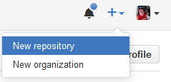
Create a Repository from the Web
- Go to your Profile Page on GitHub.com (https://github.com/USERNAME) and click the “+” dropdown to get to New Repository.
- Set the Repository name – Since you'll store your project files for the class on GitHub, name this repository after the class.
- Make sure to select Initialize this repository with a README.
- You can also click Add .gitignore and set the language to C++, this will add a file that tells Git to ignore certain types of files – like files that get built automatically every time you compile.
- Click Create repository. You will be redirected to your repository's webpage. You will be able to view files from here, as well as issues (think of a bug list, or to-do list) and wiki (if you want to keep documentation).
- Now we'll want to pull the repository down to your local hard-drive. Open GitHub Desktop.
- Select the “+” dropdown menu, and then click on the Clone tab. It should show you all of the repositories available on your GitHub account.
- Select your project, and click Clone repository.
- Choose a directory, and it will pull down the changes.
- Right-click the project on the left pane, and click Open in explorer to view the files.
- In this folder. create a new file, like “test.txt”, and add some words to it.
- Go back to GitHub Desktop, and the Changes tab should have a bullet next to it. Select the Changes tab.
- It will list your changes since the last commit. Enter a summary of your changes (“Added sample file”), then click Commit to master. This creates a “Snapshot” of your files and changes at this point in time, but it is not yet saved on the online server.
- Once you have committed your changes, click on the Publish button to push your changes to the server. Keep the defaults and click Publish (Project Name).
- When you view it from the web interface (https://github.com/USERNAME/PROJECTNAME), you will be able to see your files.

Your GitHub
Having a GitHub repository will be very useful in the long run. Using it will give you experience with source control, which is a must-have skill for the workplace.
You can keep track of all of your class work over the years, so that you don't lose it and can keep using it as reference.
You can keep track of changes made to assignments over time, so if you mess something up, you have the previous version you can rollback to.
Keeping personal projects stored on GitHub can also look good to potential employers! In some cases, companies looking for talent will find people via GitHub!

With GitHub, you can also:
- Store documentation for your project in the Wiki section of your repository.
- Keep track of bugs (or simply keep a to-do list) in the Issues section.
- Make downloads available of the executable files under the Releases section.

Other Peoples' GitHub
You can also find a lot of interesting projects on GitHub! Here are some notable ones:
Linux | https://github.com/torvalds/linux
Doom 3 and iD software games | https://github.com/id-Software
Django, a web framework with Python | https://github.com/django/django
Frogatto, a platformer game | https://github.com/frogatto/frogatto
Tiled, a 2D tile map editor | https://github.com/bjorn/tiled
AGS Adventure Game Studio | https://github.com/adventuregamestudio/ags
Prince of Persia for the Apple ][ | https://github.com/jmechner/Prince-of-Persia-Apple-II

